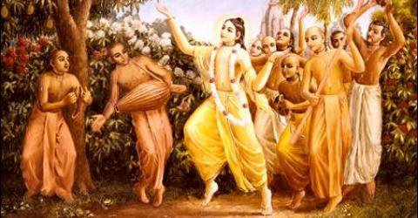

October 2010 Edition
www.soldiersofgodhead.yolasite.com
Contents
Sr.no Topics Page no.
- Govardhan Puja 4

- Varnashrama System 7

- Beware of Mayavadi Philosophy 13

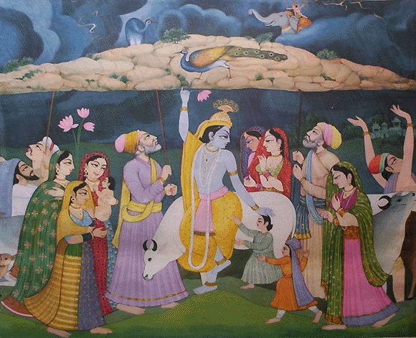
- Govardhan Puja

Once Lord Krishna’s father Nanda Maharaj was busy in preparations along with the other villagers for offering sacrifices to Indra the king of the demigods who is also in charge of providing rainfall on earth. When Lord Krishna heard of this, he protested against it and explained to His father and other villagers that the demigods are only the empowered agents of god and not god himself. It is their duty to ensure that habitable conditions prevail on earth for the survival and progress of all living beings. They need not be worshiped for doing their duty. Lord Krishna further explained that the villagers must worship the cows instead, since the cows provided them with milk and were the source of their livelihood. Lord Krishna advised His father and the other villagers to go to Govardhan Hill and worship the cows there. Being convinced of Lord Krishna’s arguments, His father and the other villagers went to Govardhan Hill as per the Lord’s advice. When Indra learnt that the villagers had abandoned the idea of worshipping him and are going to worship the cows instead, he became furious and unleashed his wrath on the village of Gokul. There was tremendous rain and thunder storm. Trees were uprooted and houses were destroyed. Seeing His devotees in despair, the Lord lifted the Govardhan Hill on His little finger and provided shelter to the villagers under the hill. Indra’s wrath continued for seven days and seven nights. During this whole time, Lord Krishna held the Govardhan Hill on His little finger to give shelter and protection to His devotees. After the seventh day, Indra realized his mistake and sought forgiveness from the Lord. Owing to his ego he had not recognized the lord in the beginning and thought of Him as an ordinary human being. But on seeing His lila, he was convinced that Lord Krishna was the Supreme Personality of Godhead and had come for the protection of His devotees. Seeing Indra’s ego shattered, the ocean of mercy Lord Sri Krishna forgave him. Owing to His having lifted the Govardhan Hill on His little finger, the Lord is also called Govardhan Giri Dhari (the one who lifted the Govardhan Hill) In remembrance of this lila of the Lord, Govardhan Puja is done on the day after Diwali. On this occasion, a hill of sweets is prepared that symbolizes the Govardhan hill and is worshiped and offered to Lord Krishna as bhog and later distributed as prasadam. This is a very unique and mouth watering celebration! Devotees also do parikrama of the Govardhan Hill in Vrindavan, India on this day. This year the Govardhan Puja is coming on the 7th of November.

Hare Krishna!

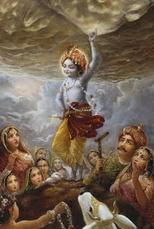
- Varnashrama System

The Varnashrama System or the Varna system as it is commonly known is a social order established by Lord Krishna Himself as He confirms in the Bhagavad Gita. According to this system, the entire population is divided into four classes depending upon the modes of material nature. There are three modes of material nature namely- goodness, passion and ignorance. The highest class in the population is that of the Brahmins or the people in the mode of complete goodness. They are characterized by saintly nature, physical and psychological cleanliness and adherence to the shastras. This class engages in occupations such as teaching, priesthood, advisory work and any profession where intelligence is the prime requirement. The next class is that of the kshatriyas or the people in the mode of passion. This class is characterized by courage, ambition and a desire to lord it over material nature. They engage in occupations such as politics, administration, military affairs etc. Their prime duty is to protect the weak and the innocent against harm. The third class is that of the vaishyas or those who are in the mixed mode of passion and ignorance. This class is characterized by a desire to accumulate large quantities of wealth for personal sense gratification and the use of unethical practices for securing one’s own interests. They engage in occupations like mercantilism, business, trade, import-export, etc. The fourth and the last class is that of the shudras or those who are completely in the mode of ignorance. They are characterized by unclean habits, no physical or psychological cleanliness, they consume meat, alcohol, intoxicants, engage in gambling and illicit sex and are completely opposed to the shastras. Thus, the lord has systematically divided the entire human society on the basis of the modes of material nature. This division is necessary for the purpose of the smooth running of the society and also for the purpose of making a systematic progress in spiritual life. By understanding one’s own nature and position in the social order, one can judge where he stands and can decide where he wants to go either further down in the social order or up in the social order. When one understands his position in the varnashrama system, he engages in the occupations prescribed for that position and doing so he becomes eligible to progress to the next higher position in the next birth depending upon the person’s karma. In this manner one comes to the position of brahmana after many many births. Having achieved the position of brahmana one engages in pious activities and becomes eligible to transcend the modes of material nature and go back home, back to godhead. It must be understood that unless one develops or acquires brahmanical qualities, one does not become a fit candidate to go back home, back to godhead. So the whole purpose of the Varnashrama system to develop brahmanical qualities in the people and to make them fit candidates to transcend the modes of material nature. By birth no one is a brahmana even if born in a family of a brahmana. At birth everyone is devoid of knowledge and hence is a shudra. Janmana Jayate Shudraha (by birth everyone is shudra). Even when Lord Brahma appeared from the navel lotus of Lord Vishnu, he was devoid of knowledge. He did not know the purpose of his existence and was thus frustrated. He inquired from Lord Vishnu about what should he do. Lord Vishnu advised him to worship Lord Sri Krishna and to seek His mercy. After a thousand years of penance by Lord Brahma, Lord Krishna became pleased with Lord Brahma and gave him the knowledge of the Vedas and asked him to create the universe. Owing to the knowledge gained by the mercy of Lord Krishna, Lord Brahma created this universe. Hence, everyone who is born in this material world is devoid of knowledge from birth and hence is a shudra. In life one must cultivate brahmanical qualities by receiving proper knowledge and instruction from a bonafied spiritual master and by serving and adhering to the instructions of the spiritual master. The knowledge that one obtains from family, friends and teachers in society is only supplementary to the prime knowledge of Krishna Consciousness that one receives by the mercy of the spiritual master. An ordinary materialist also strives to develop good qualities such as trying to speak the truth, trying to cultivate clean habits, trying to wake up early in the morning, trying to control anger, trying to be polite and generous etc. But this “trying” is most often limited to trying and never gets beyond that. This is not the appropriate method of developing brahmanical qualities. Instead of striving to develop good qualities one by one, one must directly take shelter of the lotus feet of Lord Sri Krishna and discharge loving devotional service to Him. Simply by chanting His holy name-Hare Krishna Hare Krishna Krishna Krishna Hare Hare/Hare Rama Hare Rama Rama Rama Hare Hare one can develop pure love and devotion for lord Krishna and transcending the modes of material nature, become a fit candidate to go back home, back to godhead. One may wonder that how can simply by chanting the holy name of Krishna, one achieve the highest perfection? But this is the truth. Harinama Sankirtan or chanting the names and glories of Lord Sri Krishna is the recommended method of liberation for this present age of kali yuga. In the kali yuga people are characterized by a reduced life span, reduced memory and intelligence and high levels of anxiety. Hence, it is not possible for ordinary people to do a lot of austerity and penance. Austerities are of no use in this age. Lord Chaitanya Mahaprabhu, the incarnation of Lord Sri Krishna in the Kali Yuga in the 15th century in West Bengal, India, popularized the chanting of the Hare Krishna Maha Mantra through His Sankirtan Movement. He said that “harer nama harer nama harer namaivam kevalam kalau nastey eva nastey eva nastey eva gatir anyatha” In the present age of kali yuga it is only hari nama only hari nama only hari nama by which one can achieve liberation. There is no other way, no other way, no other way. Thus, one maybe in any mode of material nature or in any position in the varnashrama system, if one chants the holy name of Lord Sri Krishna and discharges devotional service at the lotus feet of the Lord, one automatically transcends the modes of material nature and becomes a fit candidate to go back home, back to godhead.
In India however, people have misinterpreted the purpose of the Varnashrama System. They divided society not for the purpose of spiritual progress but for material progress. Being born in a brahmana family one begins to think of himself very highly and considers others as inferior although he himself may not be carrying out the prescribed duties of a Brahman. On the other hand, being born in a shudra family and not having any brahmanical qualities, a shudra poses himself as a religious man or a spiritual leader and fools the innocent and illiterate population of the rural areas and gathers large numbers of foolish and blind followers. People discriminate amongst themselves on the basis of birth, but forget the instruction of Lord Krishna that the one who sees Him in all living entities and all living entities in Him, is the one who actually sees! A pure devotee of the Lord does not distinguish between a dog or a cow, a Brahmin or a shudra, an ant or an elephant, since he sees the lord in His parmatma form seated in the heart of every living entity. Hence, Lord Krishna who is the one who established this Varnashrama System does not support the act of distinguishing between the higher and the lower classes. It is the duty of those who belong to the higher classes to help and protect those in the lower classes. In order to fulfill the purpose of the Varnashrama System, we must chant the holy names and glories of Lord Sri Krishna and become fit candidates to go back home, back to godhead.

Hare Krishna!

- Beware of Mayavadi Philosophy

‘Mayavad’ means any form of unauthorized commentary on the shastras and misleading the people on account of insufficiency of knowledge or misconception on the part of the speaker. Today, there are many mayavadi philosophers and they are very popular among the innocent people since they speak on “spiritual subjects”. For example, the ‘Speaking Tree’ section in the Times of India news paper is nothing but pure mayavadi philosophy since it promotes immersonalism, Buddhism, and draws improper conclusions from the sacred scriptures. Since it incorporates the views of mayavadi spiritualists it acts as a mayavadi mouth piece and any pure devotee of Lord Sri Krishna must guard against reading and following the things mentioned in the speaking tree. Another example of mayavadi philosophy that we can site is “spiritual discourses” by the so called spiritualists on various television channels. If the speaker is taking the people away from the lotus feet of Lord Sri Krishna, then such a speaker is a mayavadi philosopher. Such speakers although may appear to be giving a lecture on a sacred scripture like the Srimad Bhagavad Gita, but they divert the subject from service towards Lord Krishna to some other personally motivated subject. They will say that this and this is mentioned in the Gita, but they will never quote the shlok/text and the chapter where it is mentioned! They speak baselessly and just because they have a sacred book open in front of them or because they have said that this and this mentioned in the Gita, the ordinary foolish people become fooled and believe in whatever he says and in this way they are taken advantage of. A pure devotee must guard himself/herself against such mayavadi philosophy and approach the bonafied spiritual master or an authorized devotee to seek true knowledge. Now the question arises that, who is an authorized devotee or bonafied spiritual master and how to recognize him? If a devotee of Lord Sri Krishna preaches pure Krishna Consciousness which means that he promotes the chanting of the Hare Krishna Mahamantra, follows the four regulative principles-No meat eating, no drinking, smoking or drugs, no illicit sex and no gambling and regularly discharges pure loving devotional service to Lord Sri Krishna he is a pure and authorized devotee of the Lord. And when such a devotee belongs to the disciplic succession or parampara system descending from Lord Sri Krishna Himself, then he is a bonafied spiritual master. In the fourth chapter of the Bhagavad Gita, Lord Sri Krishna has mentioned that four kinds of people surrender to Him- 1. The materially distressed, 2. The one who wants money, 3. The inquisitive and 4. Those in search of the ultimate truth or knowledge. Such people are especially at risk of falling prey to mayavadi philosophy, since they are fit candidates to become pure devotees but lack in pure knowledge. Our love and devotion for Lord Krishna is like a small plant which lies vulnerable to attack by the mayavadi beasts. Hence, it is our prime duty to protect this plant of devotion from mayavadi philosophy. Chaitanya Mahaprabhu has said that those who listen to or engage in adherence to mayavadi philosophy are doomed. They commit spiritual suicide by leaving the lotus feet of Lord Krishna and engaging in some showcase spirituality like some yoga practice or social service. Social service provides only temporary relief from material pangs but the permanent cure of all suffering is Krishna Consciousness. It is not that only the materially poor people in society are the ones who are suffering. Even the rich and high society people are suffering on account of the large amount of wealth that they have amassed, lack of time, anxiety, high blood pressure, hyper tension and so on. Can social service cure this? Everyone in this material world is suffering. No amount of social service can do any permanent good. If one is truly intending to help cure the sufferings of the common people, one must help them develop devotion towards Lord Krishna so that they can chant the holy name of the Lord, transcend the modes of material nature and go back home back to godhead by remembering Lord Krishna at the time of death and never return to suffer in this material world. Hence guarding oneself against mayavadi philosophy one must engage in the chanting of the holy name of Lord Sri Krishna and discharge loving devotional service to Him and become fit candidates to go back home, back to godhead.
Hare Krishna!

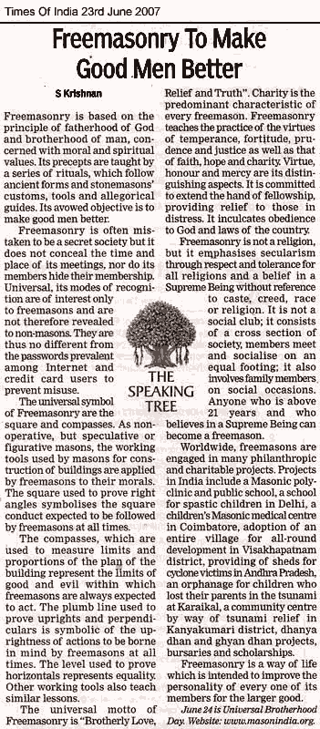
‘The Speaking Tree’ a piece of mayavadi philosophy.
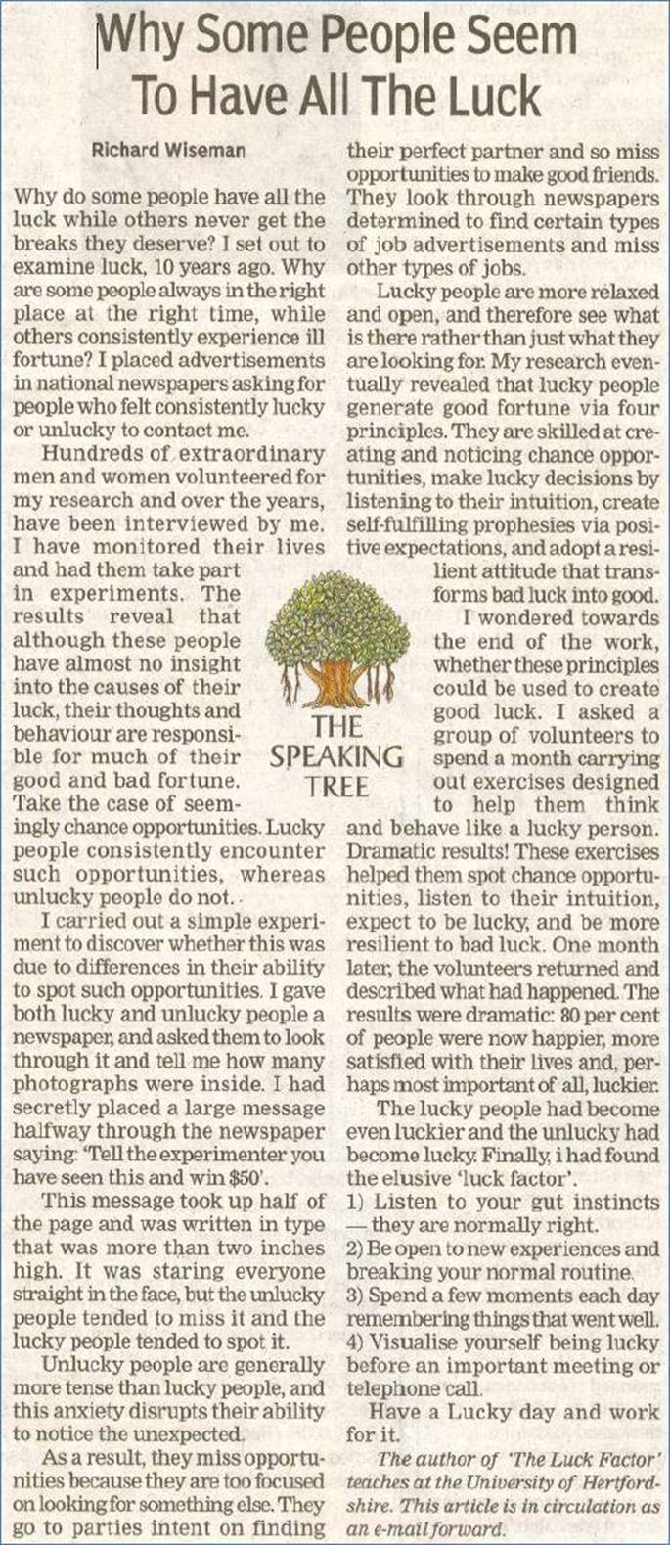
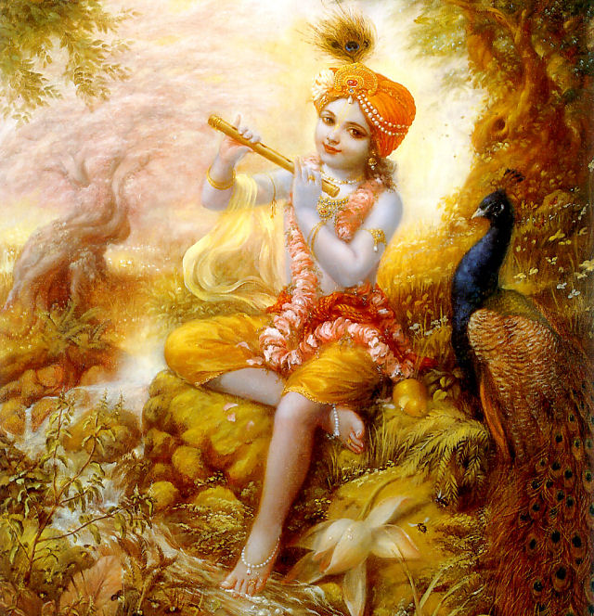
“Leave all forms of religions and duties and just surrender at my lotus feet. I shall free you from all sinful reactions, do not fear.”
–Bhagavad Gita 18.66
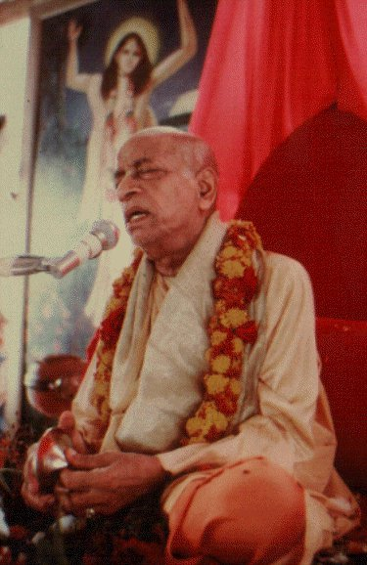
Dedicated to His Divine Grace A.C. Bhaktivedanta Swami Prabhupada, Founder Acharya of the International Society for Krishna Consciousness, ISKCON.

Written, Edited, Published and Distributed by,

Vinay Chakraborty

For receiving free monthly editions write into,
vinay.chakraborty@yahoo.com

or

visit- www.soldiersofgodhead.yolasite.com

Hare Krishna!

